# Group 1 Proposal – Fitness buddy

## Description

A fitness app that provides users with a guidance on how to perform exercises. Users can search for exercises and add them to their favourites.

## User Story

### User story for MVP

AS A healthy person I WANT to be guided through an exercise workout SO THAT I can improve my form

AS A fitness fanatic I WANT to manage a list of my favourite exercises SO THAT I can easily navigate these exercises

### User story for future releases

AS AN organised person I WANT to record the exercises I do SO THAT I can keep track of my progress

AS A healthy person I WANT to record the foods that I eat SO THAT I can monitor how many calories and nutrients I consume

AS A fitness fanatic I WANT to customise workouts SO THAT I can target specific muscles

## Acceptance criteria

Acceptance criteria for MVP

GIVEN a login form, WHEN I enter valid login details, THEN I can access the rest of the app

GIVEN a list of my favourite exercises, WHEN I click on an exercise, THEN I am presented an image and description of how to perform the exercise

GIVEN a search field, WHEN I search for an exercise, THEN I am presented with a list of exercises

GIVEN a list of exercise search results, WHEN I click ‘add to favourites’, THEN the exercise is added to my list of favourite exercises

Acceptance criteria for future releases:

GIVEN a list of my favourite exercises, WHEN I enter my rep weight, number of reps and number of sets, THEN I can view this information in the future

GIVEN a list of my favourite exercises, WHEN click on the statistics, THEN I can view a statistics graph showing my performance over time

GIVEN a food search page, WHEN I search for a food, THEN I am presented with a list of different foods which match my search

GIVEN a list of food search results, WHEN I click on a food, THEN I am presented with an option to enter a portion size

GIVEN a specific food, WHEN I enter a portion size and click submit, THEN the food is saved to today’s consumption

GIVEN a calendar, WHEN I click on a specific day, THEN I am presented with the exercises I did and the overall calories and nutrients I consumed on that day.

## Management of tasks

Tasks will be managed on a Kanban board using Trello (<https://trello.com/b/lQTeLBXp/fitness-buddy>).

## Database schema

Figure 1 below shows the proposed database schema which consists of a Users table containing the username and password (encrypted), an exercises table containing details about each exercise and a users_exercises table which maps the relationship between users and exercises.

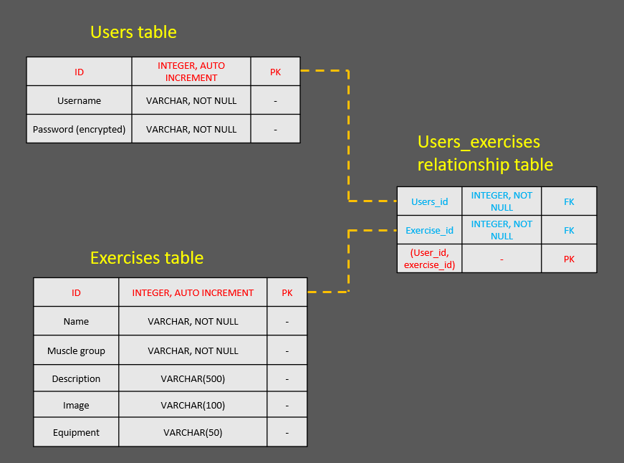

Figure - Proposed database schema

## APIs

### Wger API

### Wger is a public REST API for requesting information about exercises, including description, muscle group, equipment and images. From testing GET requests from the API, there may inconsistency in the images returned, so it may be necessary to research another API for returning exercise images.

### Link to Wger API: <https://wger.de/en/exercise/overview/>

## CSS Framework

We will adopt Semantic UI CSS framework to provide a sleek, flat and polished design for the user.

## CSS Library

We will adopt the SASS CSS library to allow us greater flexibility in our website styling through use variables, nested rules, inline imports, etc. within our CSS files.

## Template engine

We will adopt Pug or Embedded JS as our HTML template engine to make use of the simplified syntax and make our code more readable and make our HTML more reusable.

## Wireframe for Mobile App

The style theme for the application will be minimal, with a colour scheme of dark greys and greens.

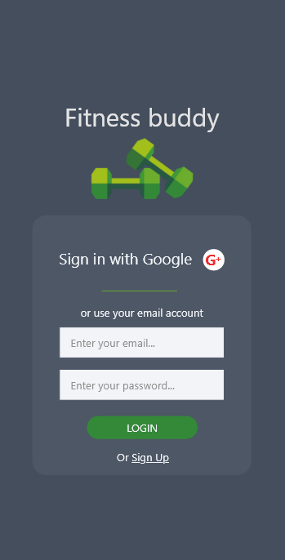 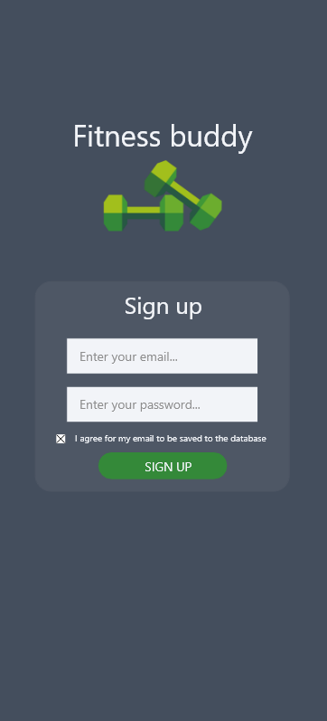

Sign up page

Sign in page

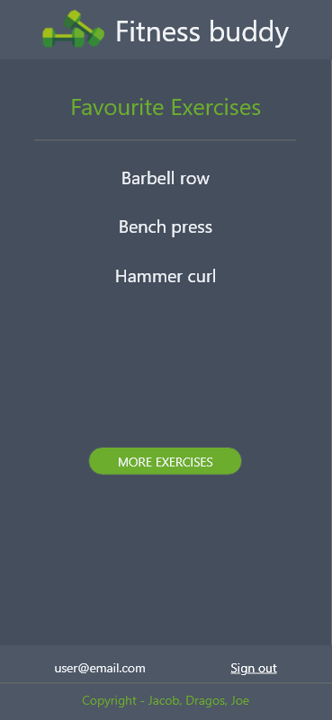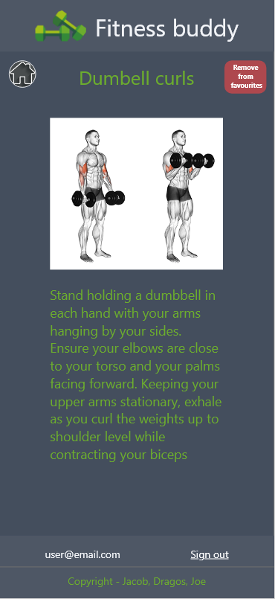

Exercise Description page

Favourites page

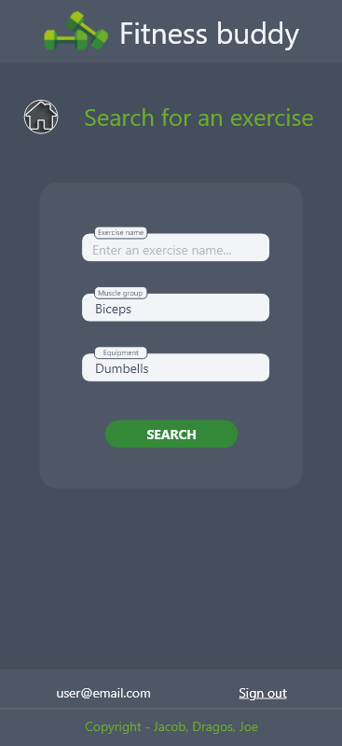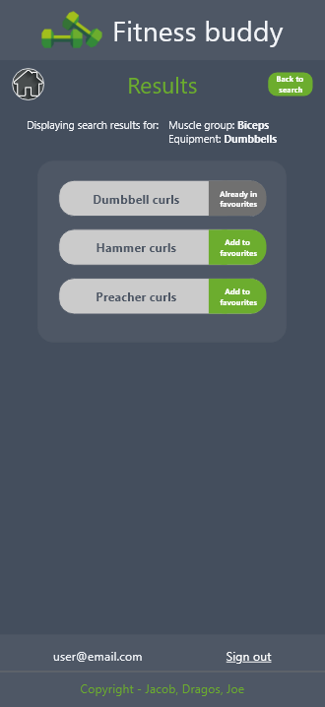

Search results page

Exercise Search page